Materi Pelajaran Kelas 6 B SDLB Negeri Cicendo Bandung
- Membaca huruf-huruf hijaiyah berharokat (tanda baca) ‘fathah’
Deret Huruf Hijaiyah Berharokat (tanda baca) ‘fathah’ | Latihan Menuliskan Huruf Hijaiyah Berharokat (tanda baca) fathah
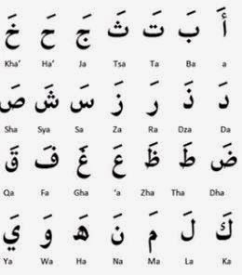 | Ja = | Ta = | A =
 | Sa = | Ha’ = | Sa =
 | Dza = | Sya = | Za =
 | Kha’= | Gha = | Ha =
 | Ra = | Qa = | Tsa =
 | Dha = | L=a | Da =
 | Tha = | Ma = | ‘a=
 | Ka = | Wa= | Zha =
 | Fa = | Ya =
 | Na = | Sha =

- Membaca huruf-huruf hijaiyah berharokat (tanda baca) ‘kasroh’
Deret Huruf Hijaiyah Berharokat (tanda baca) ‘kasroh’ | Latihan Menuliskan Huruf Hijaiyah Berharokat (tanda baca) ‘kasroh’
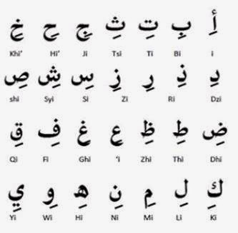 | Tsi = | Di = | Si =
 | Zi = | Dhi = | Ghi =
 | ‘i = | Ki = | Hi =
 | Ni = | Bi = | Syi =
 | Ti = | Dzi = | Fi =
 | Ri = | Ni = | Wi =
 | Zhi = | Thi = | Khi =
 | Mi = | Li = | Shi =
 | Di = | Ji = | Yi =
- Membaca huruf-huruf hijaiyah berharokat (tanda baca) ‘dhomah’
Deret Huruf Hijaiyah Berharokat (tanda baca) ‘dhomah’ | Latihan Menuliskan Huruf Hijaiyah Berharokat (tanda baca) ‘dhomah’
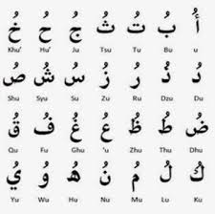 | Tsu = | Du = | Su =
 | Zu = | Dhu = | Ghu =
 | ‘u = | Ku = | Hu =
 | Nu = | Bu = | Syu =
 | Tu = | Dzu = | Fu =
 | Ru = | Nu = | Wu =
 | Zhu = | Thu = | Khu =
 | Mu = | Lu = | Shu =
 | Du = | Ju = | Yu =

LEMBAR KERJA SISWA ( LKS)
Nama : ..............................................
Kelas : .............................................
Orang tua/wali : ..............................................
Tuliskanlah huruf Arabnya:
Contoh : ka-ro-ma = كَ رَ مَ
Shi-di-qi = صِ دِ قِ
Ju-lu-su = جُ لُ سُ

- Ba-la-da .......................................................
- Ka-la-ma .......................................................
- Ja-‘a-la .......................................................
- Ka-dza-ba ......................................................
- Ba-la-gho ......................................................
- Kho-da-ma ...................................................
- Ka-ro-ma ......................................................
- Bi-si-ni ......................................................
- Di-ki-ri ....................................................
- Di-si-ni ....................................................
- Mi-ki-ri .....................................................
- Si-di-ki .....................................................
- Hi-ri-yi ....................................................
- Ki-li-mi ...................................................
- Khi-mi-si ................................................
- Ju-lu-ku .................................................
- Ku-ku-fu ...............................................
- Su-ru-tu ................................................
- Fu-ru-‘u .................................................
- Bu-du-du ...............................................

